Bharat Matrimony – Microsoft Clarity Analysis
EXPERIMENT - 06
Name | Nikhil Sainath Karmare
PRN | 1262243774
Panel | D
Subject | UI/UX
Experiment | 06

1. Clarity Dashboard

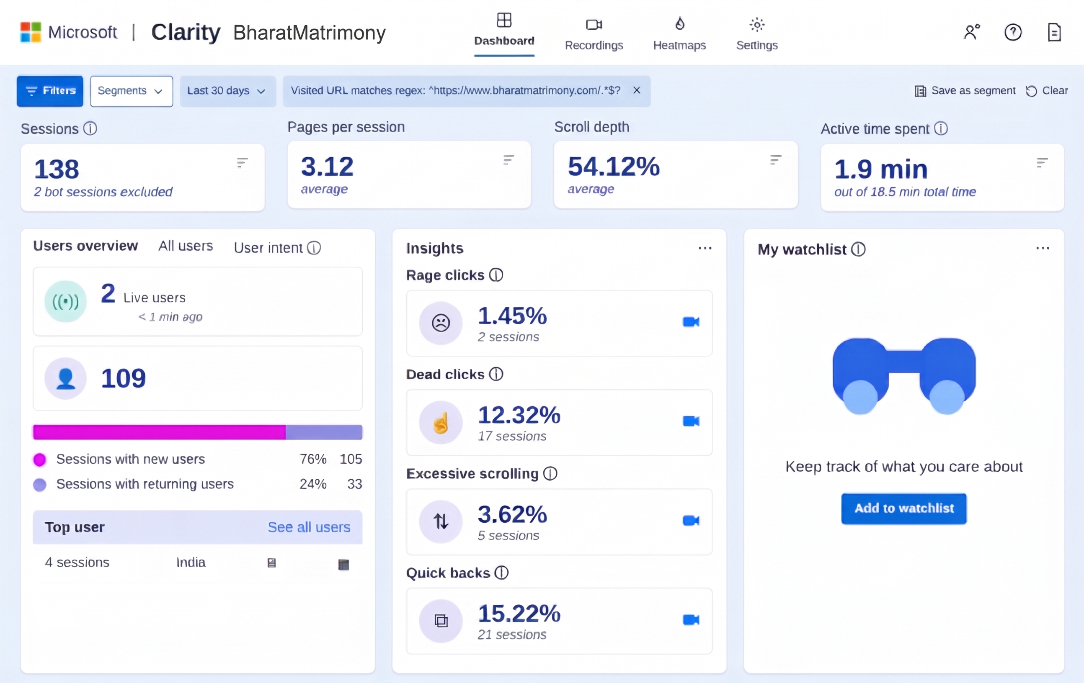

Figure 1: Dashboard overview for Bharat Matrimony (last 30 days): sessions, pages per session, scroll depth, active time and behaviour insights.

2. Session Recording 1 – Home Page

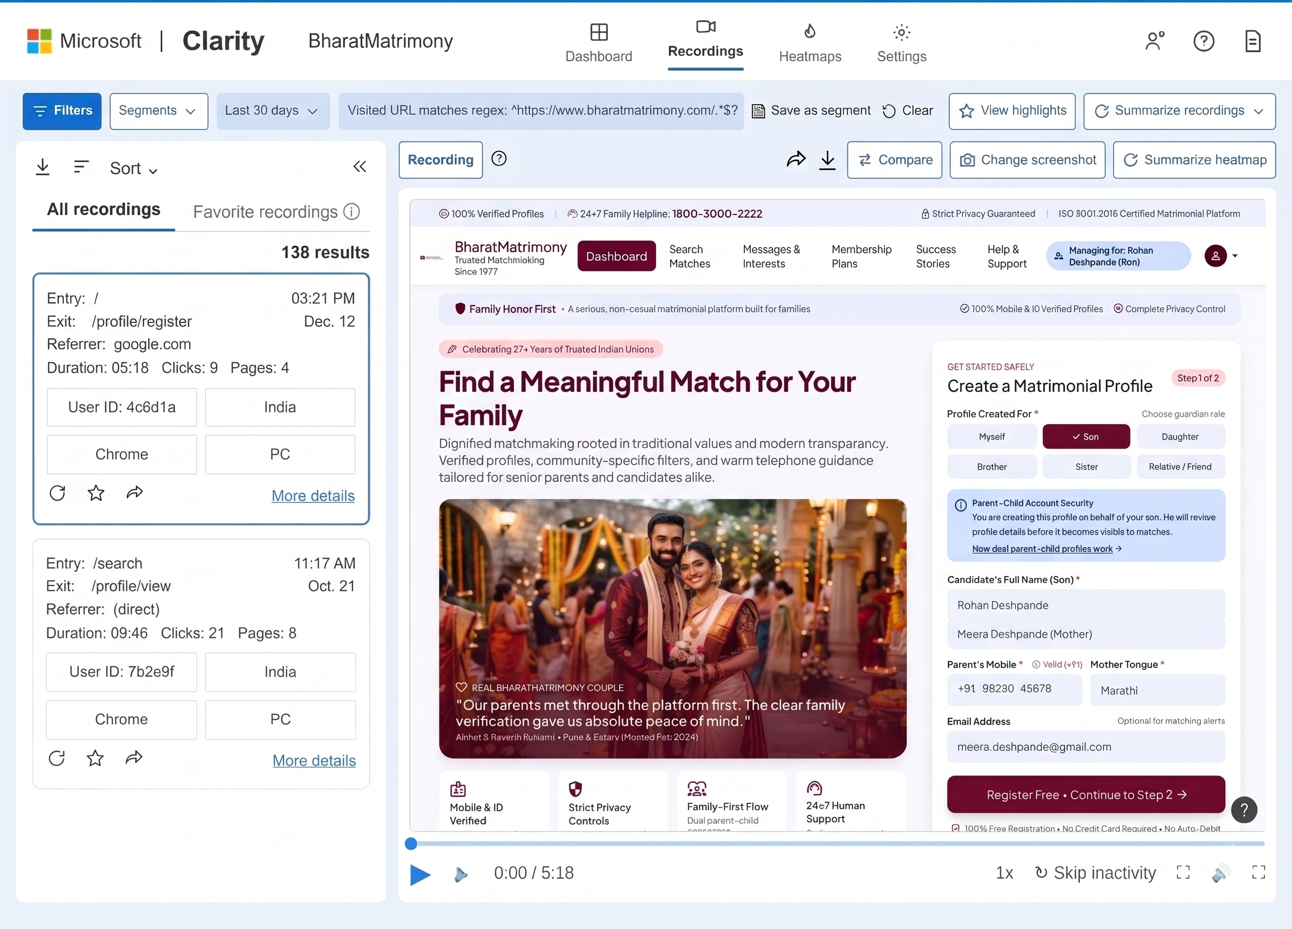

Figure 2: Session recording list with a visitor landing on the home page and hovering over the “Register”

3. Session Recording 2 – Subscription Page

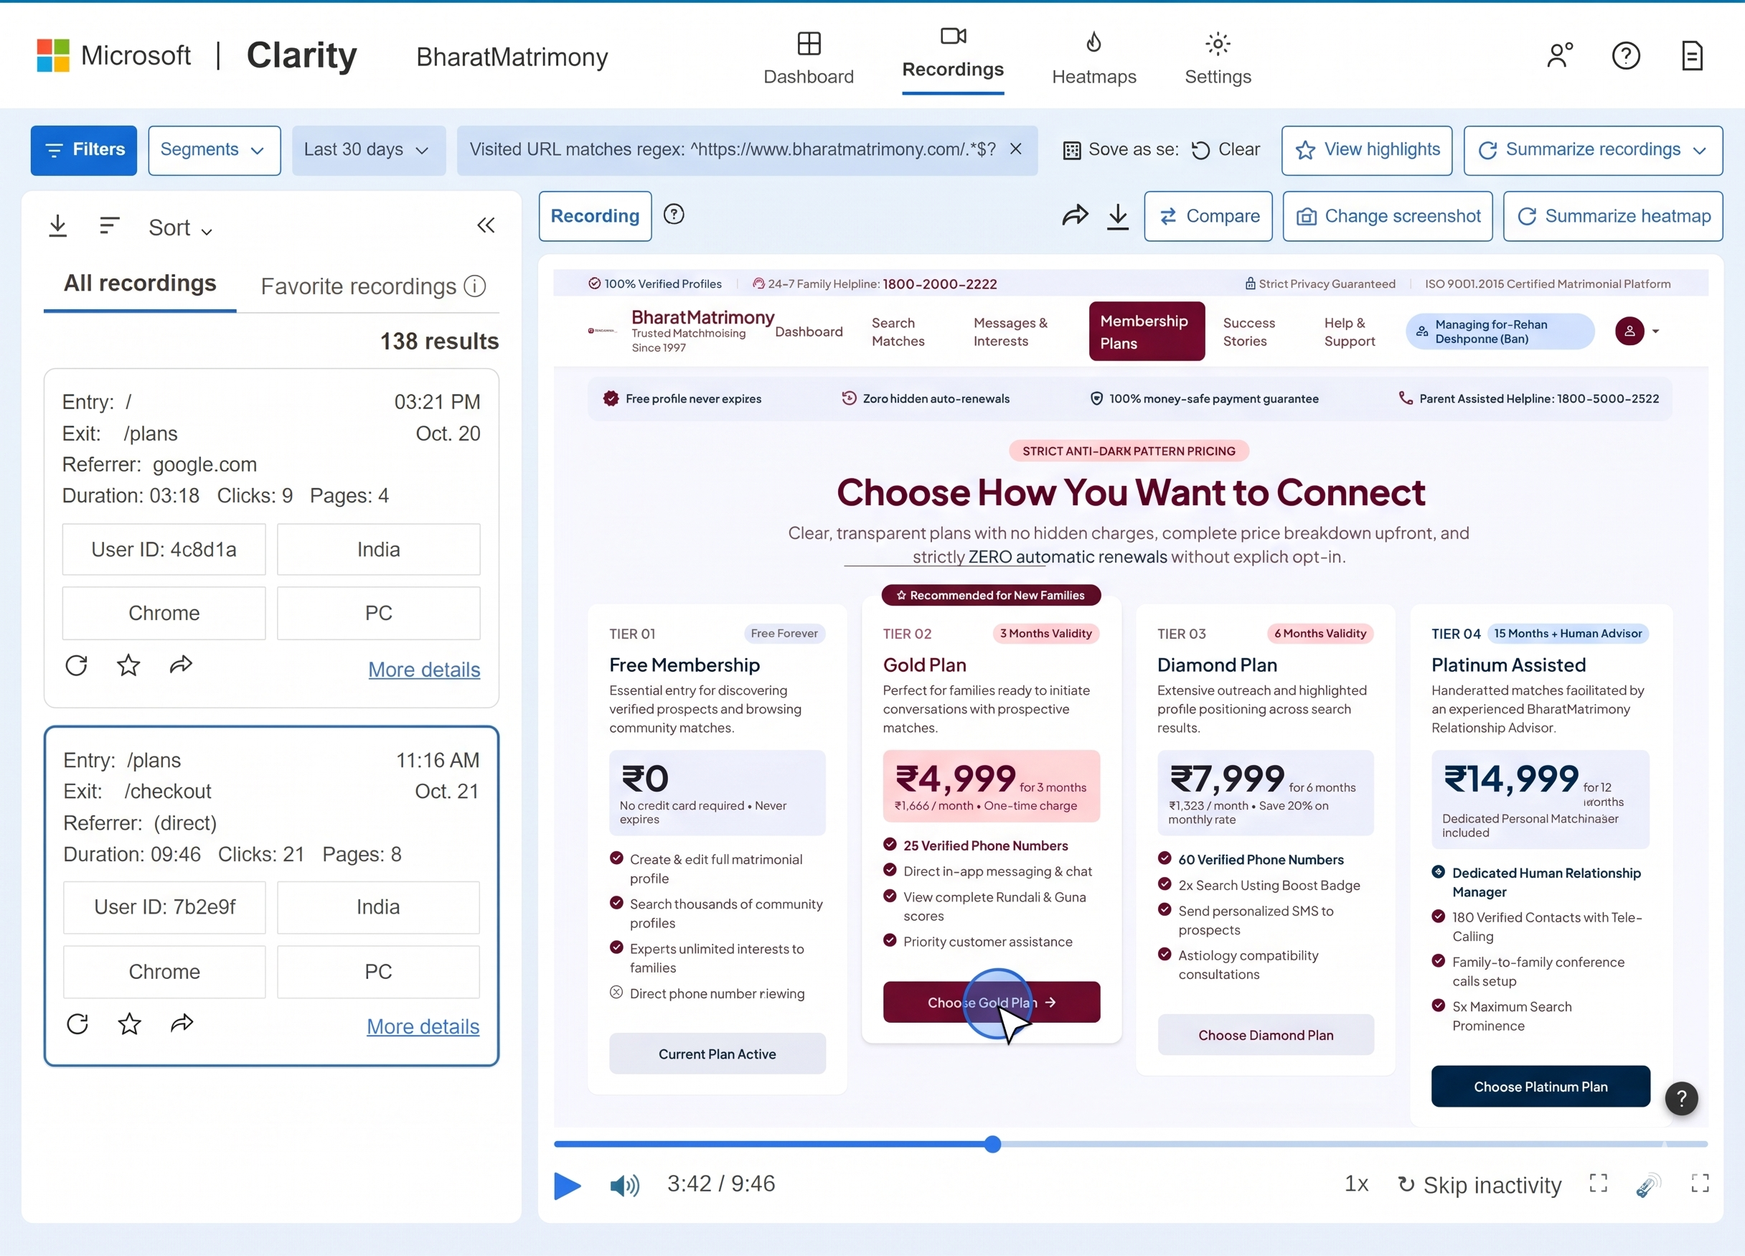

Figure 3: Session recording of a visitor on the subscription page, moving towards “Choose Gold Plan” while the reservation timer runs.

4. Click Heatmap – Home Page

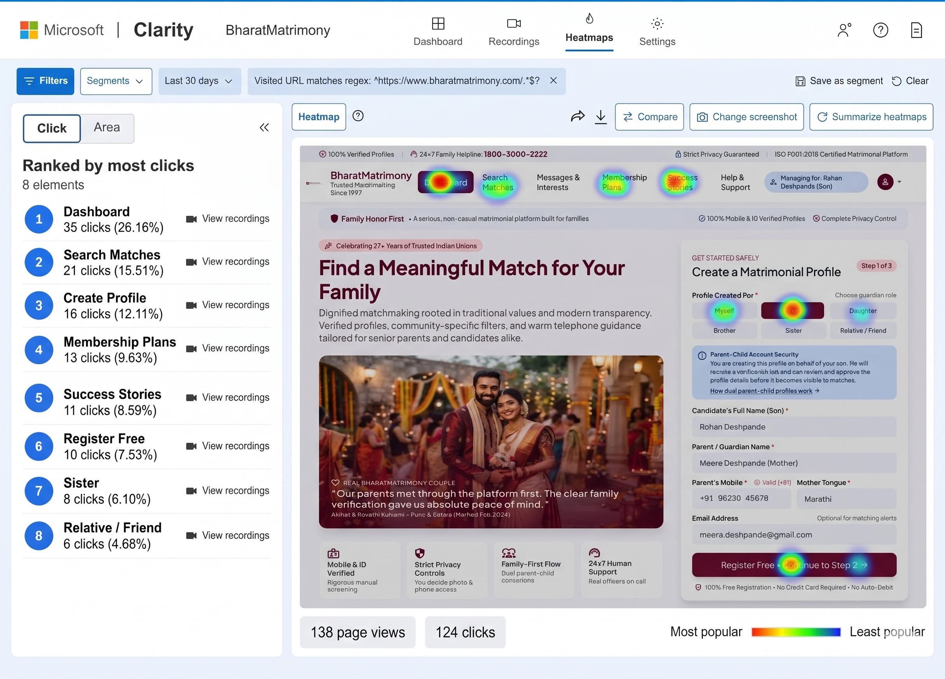

Figure 4: Click heatmap of the home page with the elements ranked by number of clicks.

5. Attention Heatmap – Home Page

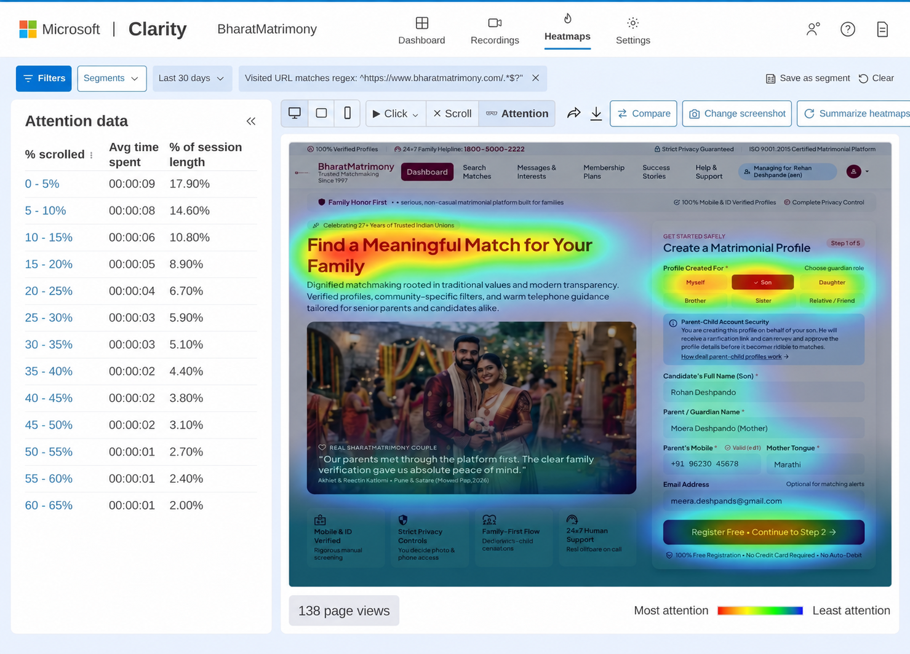

Figure 5: Attention heatmap showing where visitors spent the most time on the home page.

